**AWS Tutorial: Build a Machine Learning Model**

Time spent: 30 min

**What I built**

* Using Amazon ML to Predict Responses to a Marketing Offer

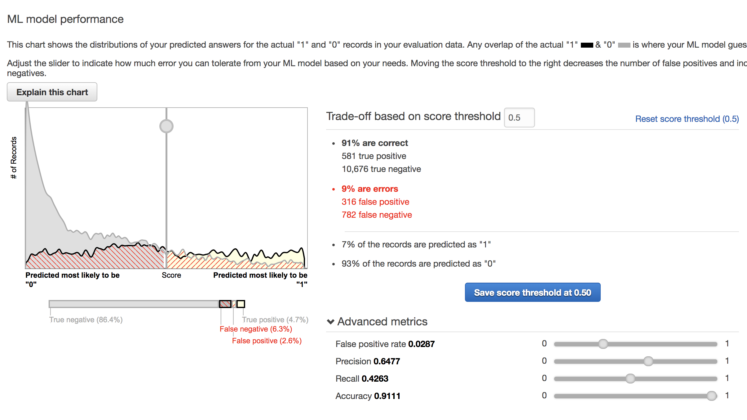

* How to build the ML model on Amazon ML
* How to do the real-time prediction

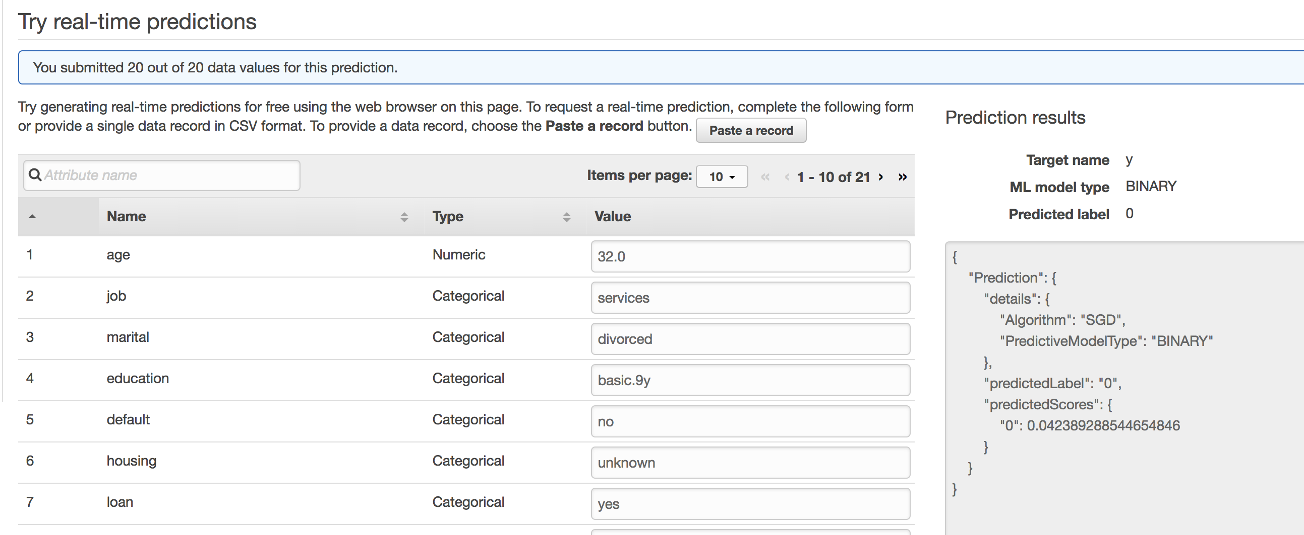

**Related component**

* Amazon ML to handle data
* Amazon S3 to store data

**Summary:**

In this section, I finished the data training and real-time prediction. I learned the mechanism of Amazon ML.